Metronome ECE 411 project notes:

PWM mode generation with Timer 2

THE FOLLOWING STEPS SHOULD BE TAKEN WHEN CONFIGURING THE CCP MODULE FOR PWM OPERATION:

1. SET THE PWM PERIOD BY WRITING TO THE PR2 REGISTER.
2. SET THE PWM DUTY CYCLE BY WRITING TO THE CCPR1L REGISTER AND CCP1CON<5:4> BITS
3. MAKE THE CCP1 PIN AN OUTPUT BY CLEARING THE TRISB<3> BIT.
4. SET THE TMR2 PRESCALE VALUE AND ENABLE TIMER2 BY WRITING TO T2CON.

Registers used:

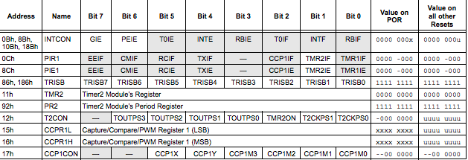

Calculation Equations:

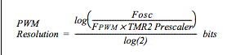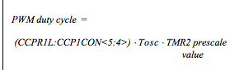Macintosh HD:Users:sally:Desktop:Screen Shot 2016-12-07 at 6.21.13 PM.png

PWM output based on previous calculations:

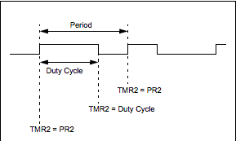

PWM block diagram:

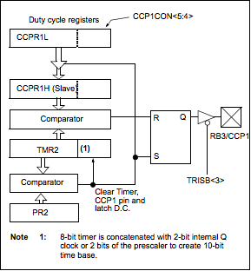

Testing: Changing the frequency calculations should change the tone of the Pizzo

Resources:

Google search

PIC16F648A data sheet